|  |  |
| --- | --- |
| **General Requirements** | |
| Functional   * FR1 -The tests will collect a score based against a marking grid based on performance of the patient * FR2 - The score should be affected by the time limits per game beforehand * FR3 -All user screen activity/movement should be logged in the database e.g. clicks * FR4 - Instructions from the SDSA manual must be shown beforehand | Non-Functional   * NFR1 - The score will be altered by time taken, wrong answers and will make use of the algorithm provided (fig 5) * NFR2 - The time limit will not shut down the games however will affect score if exceeded – should not affect gameplay * NFR3 - Game instructions can be repeated once more if required |

|  |  |
| --- | --- |
| **Game 1 – Dot Cancellation** | |
| Functional   * FR5 - A grid of dot clusters will be displayed * FR6 - Dot clusters should be able to be selected by a single click/touch from the user * FR7 - The user should be able to navigate between quadrants using buttons located at the bottom of the screen * FR8 - The game will be timed to 15 minutes * FR9 - The game will be scored via time taken, number of errors in dots missed and the number of false positives of groups cancelled in error | Non-Functional   * NFR4 - Clusters are randomised with 3-5 different dots * NFR5 - The game screen of dots should be split into 4 quadrants * NFR6 - When clicked on, dot clusters must be highlighted |

|  |  |
| --- | --- |
| **Game 2 – Road Sign Recognition** | |
| Functional   * FR10 - A selection of different road situations are displayed on screen * FR11 - Users will be able to pair sign with situation * FR12 - There are more signs than situations available for user choice * FR13 - The user will drag and drop the sign onto the situation image using a continuous click/press whilst moving * FR14 - The game will be timed to 3 minutes * FR15 - It will be scored with one point for each matched with a max of 12 points | Non-Functional   * NFR7 - Road signs will be shown like figure 1 or figure 2 * NFR8 - User can review their answers before submitting and change if required |

|  |  |
| --- | --- |
| **Game 3 and 4 – Square Matrices Directions & Square Matrices Compass** | |
| Functional   * FR16 -The user should be able to assign a card to a space on the grid * FR17 - The user will drag and drop the scenario picture into the grid spaces using a continuous click/press whilst moving * FR18 - This will continue until all spaces on the grid are filled * FR19 - Each game will be limited to 5 minutes * FR20 - Square Matrices Directions are scored 1 point for each correctly positions car and lorry, with a max of 32 * FR21 - Compass game is scored for each vehicle correctly placed with a max of 32 | Non-Functional   * NFR9 - The grid is displayed in a 4x4 grid as per figure 3, with surrounding arrows and compass directions * NFR10 - The cards will be randomised and will also feature a “no fit” area |

|  |  |
| --- | --- |
| **Game 5 – Trail Making Test** | |
| Functional   * FR22 - A board of circles is displayed with numbers from 1-25 * FR23 - The user must draw a line between the circles connecting in ascending order * FR24 - The line must be continuous with the user clicking/pressing to draw * FR25 - The test will be timed with no limit | Non-Functional   * NFR11 - Numbers in circles are randomised * NFR12 - Circles must have sufficient spacing to draw lines between - figure 4 |

|  |  |
| --- | --- |
| **Overall Games** | |
| Functional   * FR26 - After each game, user should be able to submit answers * FR27 - Each game will be timed and should be in order of Dot Cancellation, Square Matrices, Square Matrices Compass, Road Sign Recognition and Trial Making Test * FR28 - Feedback should be provided * FR29 - Images used will be royalty free * FR30 - Score should be saved to a database along with patient details | Non-Functional   * NFR13 - Answers should be stored individually based on the game * NFR14 - Time limits will be set as per the SDSA manual * NFR15 - The feedback will only be presented after the test has concluded * NFR16 - Images should conform to the GNU General Public License (GPL) |

|  |  |
| --- | --- |
| **Login** | |
| Functional   * FR31 - The clinician should have a screen where patient data and country preference is added before test commences | Non-Functional   * NFR17 - A screen will show when the device is in test mode |



Figure 1



Figure 2

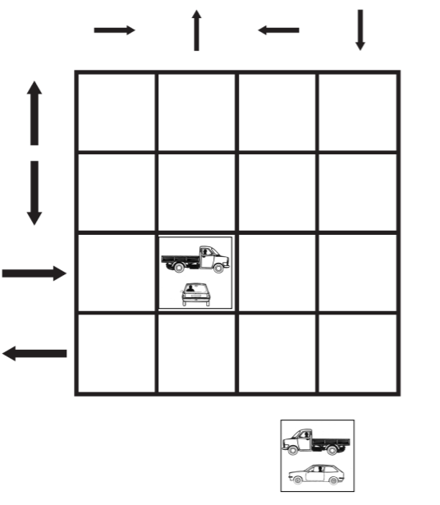

Figure 3

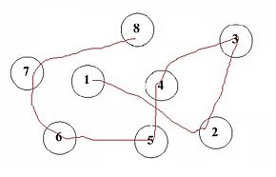

Figure 4

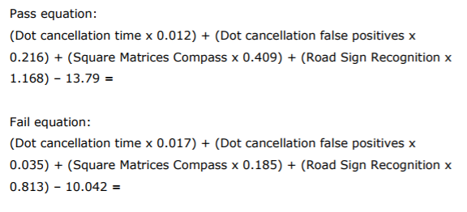

Figure 5